# After Effects Remove Green Screen

## Key Light 1.2

00H:02m:32s

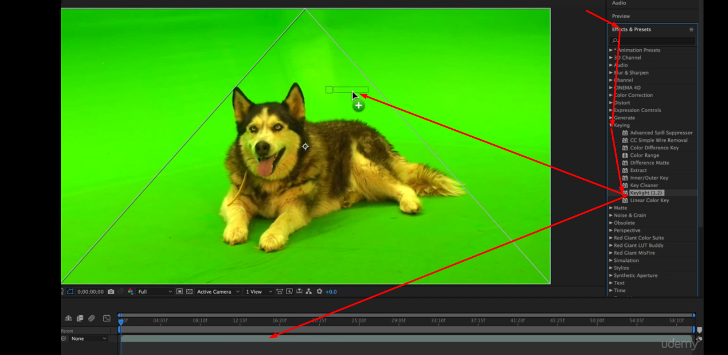

Mask this

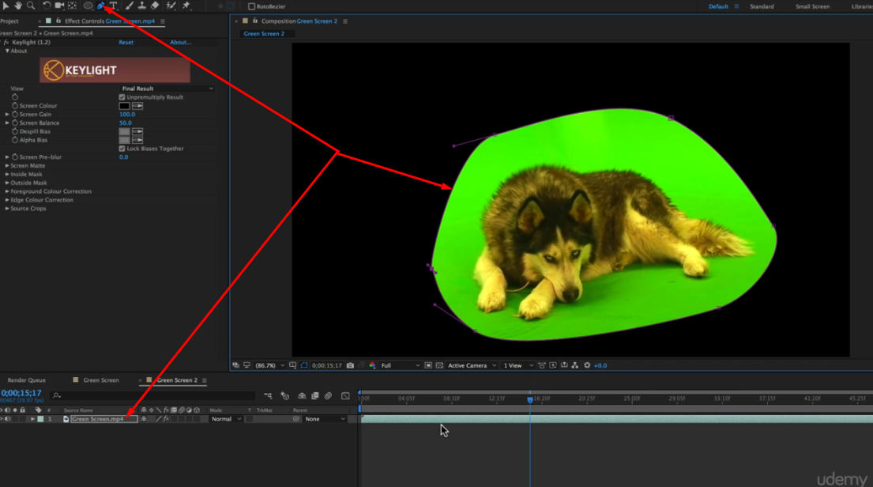

Use the effect from Effect Control

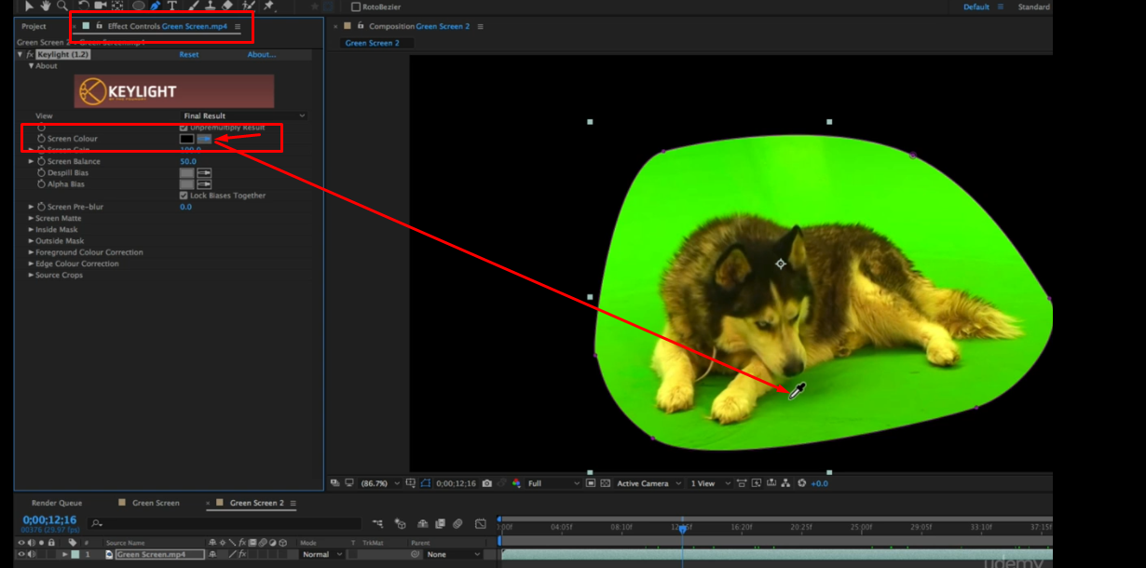

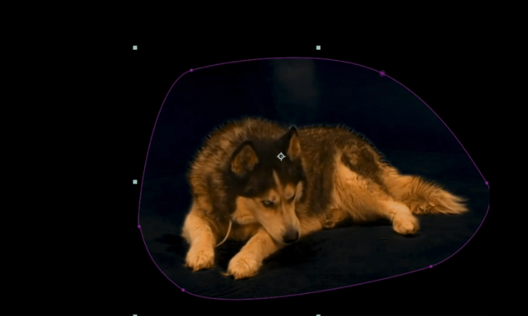

White dots or black spots may be left over

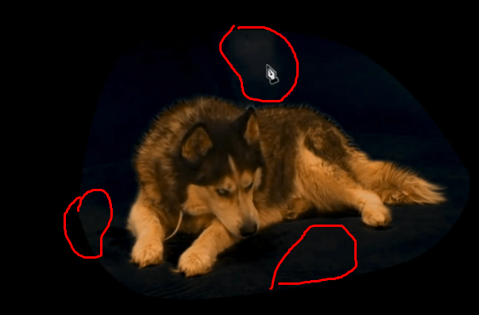

## To clean Up Green Screen Footage

00H:03m:41s

Screen Gain might help

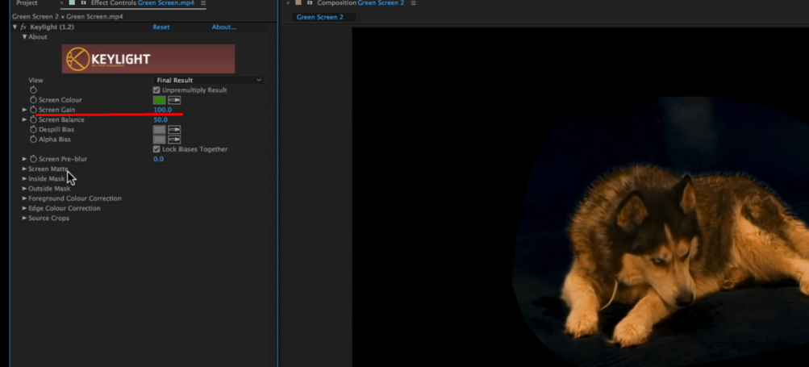

Or You can go to the screen Matte Option

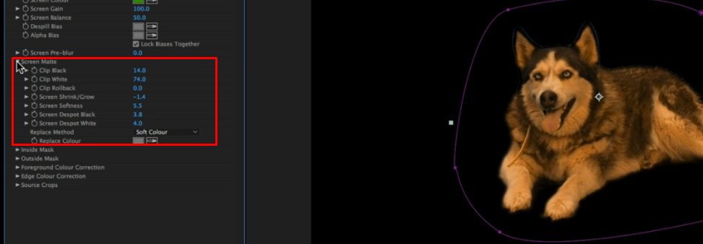

Use Solid Background to identify problem –

